Light Runners stereo space mission e/po

Evaluation

grant #nnx08ba90g

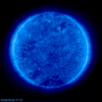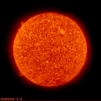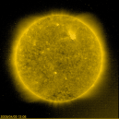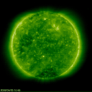

Anne Knopp, Science Instructor, Virginia School for the Blind, Staunton, VA, May 27, 2009 ... I wanted to write to tell you how I felt about Marty [Quinn] and [the Light Runners] project. To me, it is of the highest caliber and unique. I have never seen or heard of anything similar to it, and the possibilities in the classroom to enhance learning and interest in space for the blind are phenomenal. I am always writing in my goals each year that I am continually searching for new ways to inspire my students to love science, and I can say unreservedly that this project falls in that category. I am very glad to have met this man and very pleased to endorse all that he proposes to do. Thank you.

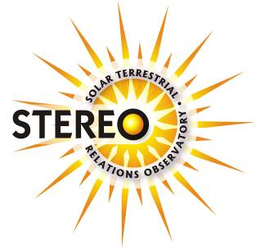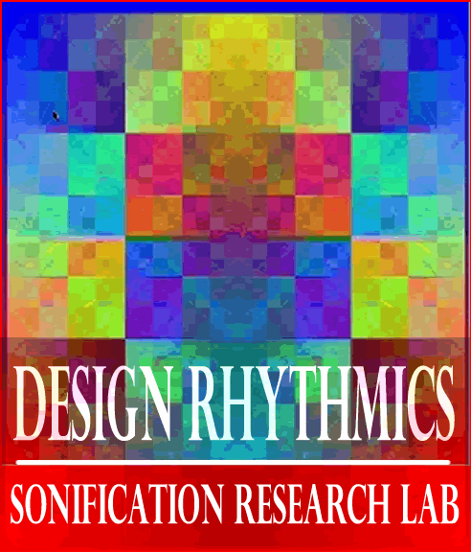

To access bookmarks within the text,
hold the CTRL key and click on the hyperlinked text.
To return to cover page

Press {CTRL}{Home}

TABLE OF CONTENTS

Overview

PART I: Evaluation
- Venue
- Design
- Exhibit Set-Up
- Sessions
- Presentation
Exhibit 1: Script Prepared for Presenter

PART II: Grant Compliance
Exhibit 2: Light Runner Program Cities and Events Completed

PART III: Analysis
- Data Collection
- Video Scoring
- Case Studies
  - Tuesday, June 2, 2009, 10:30 AM Session
  - Tuesday, June 2, 2009, 1:00 PM Session
  - Wednesday, June 3, 2009, 9:00 AM Session
  - Wednesday, June 3, 2009, 12:30 PM Session

PART IV: Conclusions and Recommendations
- Conclusions
- Recommendations incorporating Teachers Comments and Testimonials

Light Runners stereo space mission e/po

Evaluation

Communicating NASA’s Solar TEerrestrial RElations Observatory (STEREO) science to the blind and visually impaired communities
using the “Walk on the Sun” Interactive Image Sonification Exhibit Technology

Prepared by Elizabeth S. Webbink, PhD, in consultation with Principal Investigator Jeanne Gerulskis, Co-Investigators Marty Quinn and David McDonald, M.Ed.

OVERVIEW
This evaluation provides an initial indication as to the effectiveness of the Light Runners’ “Walk on the Sun” exhibit in using sonic representations to communicate scientific data to its target audience, the visually impaired.
Part I “Evaluation Design” describes the evaluation process which was based on an analysis of videos of eight presentations of the “Walk on the Sun” exhibit made to small groups of students at the Maryland School for the Blind over a two-day period in June 2009.
Part II “General Compliance” uses qualitative information from these sessions and elsewhere to evaluate the extent to which the project met specific goals stated in the grant application.
Part III “Case Studies” uses quantitative data from four of the evaluation sessions to assess Light Runners technology’s ability to convey visual information to the visually impaired participants.
Part IV “Conclusions and Recommendations” summarizes the evaluator’s findings.
Overall, the evaluator concludes that Light Runners exceeded expectations of the grant with regard to bringing NASA’s Solar TErrestrial RElations Observatory (STEREO) space mission to the attention of the public including the visually impaired and providing a workable proto-type of a technology that could be adapted for effective applications in educating the visually impaired. The major deficiency was the lack of a presenter/co-presenter during the presentation sessions with the complementary pedagogical and content skills required to better utilize the technology to deliver science education to the visually impaired. Where the program succeeded in this area was in demonstrating the possibilities and inspiring several such educators and potential collaborators to make suggestions for further development. These possibilities might be pursued in an intensive deployment of the technology in the classrooms of a partner school for the purposes of developing a student curriculum and professional development seminar for educators. This would provide the basis for a more rigorous evaluation of the effectiveness of the technology in science education for the visually impaired.
PART I. EVALUATION
A. VENUE
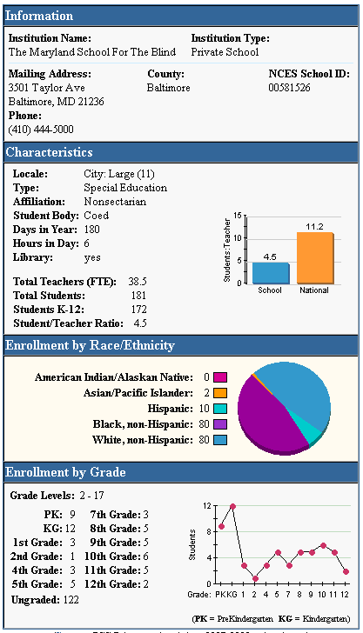
The Maryland School for the Blind is a private, nonprofit school dedicated to educating children and youth from infancy to age 21 with visual impairments, including those with multiple disabilities, and providing a diversified sample of participants for this study.

SOURCE: National Center for Education Statistics, Institute of Education Sciences
http://nces.ed.gov/
globallocator/
sch_info_popup.asp?
Type=Private
&ID=00581526
B. EVALUATION DESIGN
Over two days in June 2009, Co-Investigator Martin Quinn conducted 45-60 minute sessions introducing the “Walk on the Sun“ exhibit to eight groups totaling 55 students from the Maryland School for the Blind. The sessions were videotaped for subsequent analysis. Prior to the sessions, Primary Investigator Jeanne Gerulskis, Co-Investigators Martin Quinn and David McDonald, M.Ed and Evaluator Elizabeth Webbink developed a script (see Part II.F below) with the concepts to be covered to facilitate collection of data from the videos. A data set was constructed from the video records and analyzed in relation to the project’s objectives.
C. EXHIBIT SET-UP
As depicted below, the Light Runners’ “Walk on the Sun” exhibit was set up in the auditorium of the Maryland School for the Blind. The exhibit consists of two stands suspending a data projector between them, which produced a 7’ x 7’ image on the ground below. A visual surveillance camera attached to the projector tracks and uses the participant’s movements over the image to select pixels from the image. Each image is made up of one million pixels. The color and brightness of the selected pixels determine the synthesized instrument and pitch to be played. For example, a light blue pixel would be “sonified” as a high-pitched guitar note. A dark yellow pixel would be represented by a low note on a vibraphone.
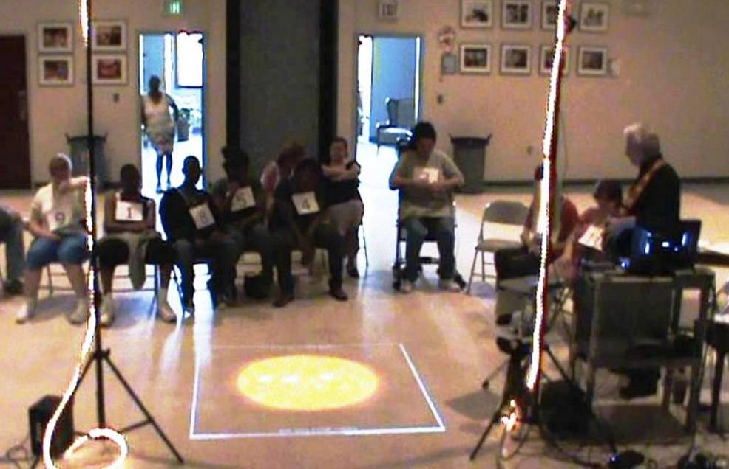

D. SESSIONS
Students were brought in to the auditorium in groups of ten or less. Teachers presented completed forms which had previously been supplied to the school requesting parental/guardian permission to video the students. Student without permission slips were seated outside the range of the camera. Where teachers requested that these students be allowed to try out the technology, the camera lens was covered. Students with permission slips were given numbered bibs to facilitate data collection from the videos. Martin Quinn conducted the presentation for each group and spent approximately half of each session guiding individual students across the projected images so they could be recorded experiencing image sonification first-hand.

# | Session | # of Bibbed Participants
1 | Tuesday 10:30 a.m. | 6
2 | Tuesday 1 p.m. | 8
3 | Tuesday 2 p.m. | 5
4 | Wednesday 9 a.m. | 9
7 | Wednesday 10 a.m. | 5
5 | Wednesday 11 a.m. | 8
6 | Wednesday 12:30 p.m. | 6
8 | Wednesday 1:30 p.m. | 8

E. PRESENTATION
Each session started with a brief description of the purpose of sonification research, NASA’s Solar TErrestrial RElations Observatory (STEREO) space mission and funding of the project, and the physical setup of the exhibit. The script covered concepts to be evaluated, e.g., ability to
- discern variation in pitch and map pitch to brightness (see student below walking across image)
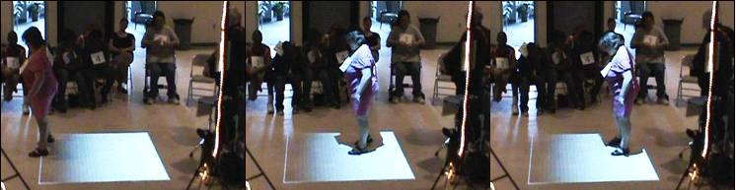
- discriminate between various instruments and map to color or passage of time, and
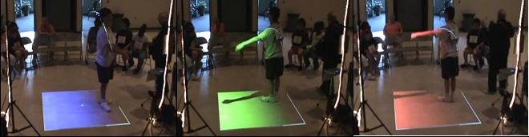
- use this information to explore solar phenomena such as hot spots, corona, and solar winds.
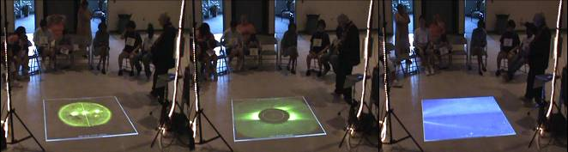
Hot spots Corona Solar winds

Exhibit 1: Script Prepared for Presenter

Design Rhythmics
SonificatioN Research Lab
Getting Science Through Music
SCRIPTED PRESENTATION
- Welcome to Walking on the Sun.
- Here we are able to explore images of the Sun from the STEREO space mission and hear the image as music.
- This is a work in progress; your participation will help us improve this exhibit, so we thank you, NASA thanks you, and future exhibit participants thank you!
- A digital image of the Sun is projected onto the exhibit floor.
- Please take a walk on the exhibit floor and see what happens.
- Digital images are made up of tiny components called pixels. As you walk, your body is being tracked by the exhibit projector and used to select pixels in the image as you walk over it.
Let them try it for 10 to 15 seconds.
- You will hear the pixels as pitches played by different instruments.
- The pitch is determined by the pixel: the brighter the pixel, the higher the pitch.
Show them the brightness key and let them explore it.
- Color determines the instrument that plays that pitch.
Play them the color key, again let them explore that one; explain what the colors mean; that, like sound, they are an interpretation of data.
- Now, let’s go back to the blue image of our sun.
- Normally our sun appears white or yellow high in the sky, and orange or red if it is just rising or setting.
- The blue sun represents the Sun recorded in ultraviolet light at up to one million degrees - the higher the pitch, the brighter the spot on the image and the closer it is to one million degrees at that location.
- Explain UV light: Normally we can’t see UV light – it’s the light that gives us a suntan (or sunburn). Scientists color code the image, in this case in blue, so that e can see it. But this is a choice – they could also code it by using sound, or heat, or vibration.
- Explain significance of altitude above photosphere.
- Get the participant comfortable with the setup and context
- Note that the image that you are walking over covers a 10’ x 10’ area.
- When you are near the edge of the image, is the pitch high, medium or low? [Ans: Low]. That means you are literally standing in space, which is the dark area outside the Sun.
- Now walk toward the middle of the image and listen to what happens.
- Did the pitch go up or down? [Ans.: Up] This signifies that you entered a brighter area of the image – you walked on the Sun.
- Explore the colors and changing brightness on the surface of the Sun. [Note: leave out textures; there’s no explanation of how to detect textures ]
- Walk all the way across the image, from the darkness of space, across the surface of the Sun, back into the darkness of space on the other side.
- Can you find the limb (outside edge) of the Sun? Can you trace the limb of the Sun?
- We have four colors of the Sun that we can explore today. Each color represents a different temperature range. Stand on the Sun and we’ll change the images.
- Here is a Red image of the Sun.
- Red and black are represented by a piano.
- The filter used to create red images highlights features of solar activity that occur at around 80,000°.
 | EIT 304
- Here is a Blue image of the Sun.
- Blue is represented by a nylon string guitar (which sounds like a harp).
- The filter used to create blue images highlights features of solar activity that occur at around 1,000,000°.
- Did you notice the instrument change?
 | EIT 171
- Here is a Green image of the Sun.
- Green is represented by a steel drum.
- The filter used to create green images highlights features of solar activity that occur at around 1,400,000°.
 | EIT 195
- Here is a Yellow image of the Sun.
- Yellow is represented by a vibraphone.
- The filter used to create yellow images highlights features of solar activity that occur around 2,200,000°.
Select an image with hot spots, or if they move over a hot spot:
- Do you hear those high pitches?
- Those are the hot spots.
Explain hot spots to the participant – what are they? Why are they there? | EIT 284
EIT IMAGES http://sohowww.nascom.nasa.gov/data/realtime/image-description.html

- Take participant(s) through the sonification designs of meridian line and circle.
- If we listen to the pixels down the middle of each image as a chord of music and play the images in quick succession, we can hear the Sun rotate.
- Show them the button which allows them to play the images as a movie.
- We can hear the changing surface of the Sun and hear hot spots as they cross the meridian line.
- Play a black area, beginning of hot spot, and crescendo.
- And as the hot spots cross the meridian line, we can hear them as high pitches.
- Let’s listen to the yellow sun, as the yellow image best highlights the hot spots. [explain why]
- Present the sonification of date and time as the percussion sounds.*
- The shaker sound represents the minutes as they change and pans left to right over the course of an hour.
- The ride cymbal represents the hours of the day and again pans left to right from 12 AM to 11 PM.
- The conga sounds are the days of the months and move from the left to the right speaker over the course of a month.
- The bass drum is the month and again pans from left to right over the course of the year.
- And finally, the year is a crash cymbal which pans left to right over the course of three years, from 2007-2009.
- Let’s listen to the Sun, using the yellow 2 million degree camera, over the course of a year. Does the Sun change much? Do the hot spot areas last more than a month?
* This section is optional and should be reserved for students from an advanced class with sufficient time to absorb it:
- Present the corona imagery
- The Sun has an atmosphere, above its visible surface of hot roiling gas. It is called the coronosphere. We usually can’t see it or photograph it because the incredible brightness of the Sun overwhelms it. But if you block out the Sun – either naturally, by the Moon during an eclipse – or artificially, by using a disc in your telescope – the corona becomes visible.
- Two cameras on the STEREO satellites allow us to see and hear the corona change.
- If we sonify – or, assign sounds to - points that lie in a circle just beyond the blocked-out Sun, in the area of the corona, we can listen to changes in the corona through music. When the pitch is higher, that area is brighter, and if it is lower in pitch, it is darker.
- Does the corona change? Let’s listen to it over the course of a year and then we can talk about it.
- Explain the Solar Winds
- One of the cameras on the STEREO space mission is looking not at the Sun, but at space just to one side of the Sun so that we can actually see solar winds.
- To hear the changes in this image, we place an auditory line near the side of the image which is closest to the Sun. [Explain “auditory line” and how it is indicated]
- This allows us to hear the changes in the solar wind.
- We can sometimes hear planets as their orbits cross through the images of the solar wind.
- If planets should cross the audio line while we are exploring the solar wind, they will either make a very high or a very low pitch, because their brightness saturates the entire column of pixels in the camera image. Sometimes this saturation is all white - which produces a very high sounding chord, or all black – which produces a very low chord.
- Let’s listen to the solar winds over the course of a year and then we’ll talk about it.
PART II. GRANT COMPLIANCE
Supporting NASA’s goal of making the scientific findings from its missions widely accessible, Light Runners focused on developing a touring outreach program specially targeted to include the underserved population of the blind and visually challenged, using novel musical forms to disseminate STEREO Space Mission images to the general public. In addition to other goals, the grant proposal indicated that the Light Runners program would run special programs for the blind and visually impaired at museums and science centers so they could interact with the exhibit without distraction. Light Runners exceeded its target goal to bring the museum exhibit “Walk on the Sun” to at least 12 cities and/or conferences. The table on the next page shows venues for the Light Runners exhibit.

“ A Walk on the Sun: Knowledge Through Music". Light Runners, NASA Goddard Space Flight Center LaunchFest, September 2008. Image courtesy Marty Quinn

Exhibit 2: Light Runner Program Cities and Events

YEAR | MONTH |  | DAY |  | DESCRIPTION | LOCATION |  |  |  | #
Stationary version on permanent display at the McAuliffe-Shepard Discovery Center (visitor count = March 6 2009-March 31, 2010 = 88,044 x est. 25% visiting exhibit) |  |  |  |  |  | Concord |  | NH |  | 22,011
2008 | JUL  AUG |  | 29 to  1 |  | The Exploratorium | San Francisco |  | CA |  | 4,000
2008 | SEP |  | 11 |  | National Federation of the Blind | Baltimore |  | MD |  | 200
2008 | SEP |  | 13 |  | NASA Goddard Space Flight Center LaunchFest | Greenbelt |  | MD |  | 3,000
2008 | SEP |  | 26 |  | FutureTech Convention of the Blind – Holiday Inn | Concord |  | NH |  | 200
2008 | OCT |  | 1 |  | Christa McAuliffe Planetarium: NASA's 50th birthday party | Concord |  | NH |  | 70
2008 | OCT |  | 11 |  | University of New Hampshire: Celebration of the opening of Demeritt Hall, the new physics building | Durham |  | NH |  | 220
2008 | OCT |  | 18-21 |  | Association of Science-Technology Centers (ASTC)  Conference -- NASA Booth | Philadelphia |  | PA |  | 500
2008 | NOV |  | 18 |  | California Polytechnic State University: Mars Within Reach Library Exhibit Opening and Workshop for the Blind | San Luis Obispo |  | CA |  | 24
2008 | NOV |  | 14-15 |  | California Polytechnic State University: Mars within Reach kickoff. Special exhibition to run for two months on  sonification of Mars data. | San Luis Obispo |  | CA |  | 147
2008 | NOV |  | 24 |  | Miami Lighthouse for the Blind | Miami |  | FL |  | 100
2008 |  | DEC | 3 | Miami Science Museum |  |  | Miami |  | FL | 2000
2009 |  | FEB | 10-14 | NASA GSFC Day at the State Capitol |  |  | Annapolis |  | MD | 600
2009 |  | APR | 4 | Virginia Air and Space Museum |  |  | Hampton |  | VA | 3000

Exhibit 2: Light Runner Program Cities and Events (continued)

2009 | APR |  | Virginia School for the Deaf and Blind | Staunton | VA | 20
2009 | MAY | 8-10 | Maryland Science Center - A Salute to Our Place in Space | Baltimore | MD | 600
2009 | JUN | 2-3 | The Maryland School for the Blind | Baltimore | MD | 55
2009 | JUN | 7-14 | South Florida Museum | Bradenton | FL | 811
2008 | JUN | 22 | Lead America Program for HS Students | Needham | MA | 320
2009 | JUL | 14 | Lead America Program for HS Students | Needham | MA | 300
2009 | JUL | 15-18 | The Sci-Tech Center of Northern New York | Watertown | NY | 158
2009 | JUL | 3-8 | NFB National Convention | Detroit | MI | 2500
2009 | MAY | 13 | Oyster River School | Durham | NH | 200
2009 | MAY | 23 | Green Acre Baha’i School | Eliot | ME | 60
2009 | JUN | 24 | Laban Institute | New York | NY | 19
2009 | JUL | 8 | Perkins School for the Blind | Boston | MA | 32

PART II. GRANT COMPLIANCE (continued)
In addition to the “Walk on the Sun” touring outreach exhibit, Light Runners’ grant application specified the following goals for the project:
Teach solar science and the science and art of sonification of data.
The evaluation’s case studies suggest that visually impaired students can grasp the concept of data sonification, mapping variation in instrument and pitch to color and brightness and in some cases to the passage of time and solar phenomena such as hot spots. Extension of this mapping to more complex concepts is possible over time, but requires a more intensive implementation in collaboration with a content expert skilled in teaching science to the visually impaired.
Inform people as to how pixel data is translated into music.
Students experiencing the exhibit during the evaluation at the Maryland School for the Blind showed strong interest in making music through their movements over the images. Through the music, they were able to identify variations in color, brightness, and time. More focused guidance by the presenter and longer exposure for individual users will be necessary to determine if users’ grasp of the mapping concepts involved in sonification can be directed to deliberately creating, for instance, a musical composition of their own design.
Instruct users about the STEREO space mission, its two spacecraft and be able to select image data from either craft… They will learn about the instruments on board, especially the eight cameras that are easily selectable using MIDI pad controllers.
During the evaluation, the exhibitor provided information on the STEREO space mission at the beginning of each presentation, but focused during the balance of the presentation on using the solar images to instruct students in mapping, e.g., matching variations in instruments and pitch to color and brightness, so the selection of image data from different STEREO instruments or review of the STEREO instruments themselves was not a focus during the time when the participants were engaged with the exhibit There were several situations with higher functioning students who quickly grasped the sonification concept and were sufficiently engaged to ask questions that led to a discussion of more technical aspects of the project.
Evaluate the results of interacting with the exhibit on both qualitative and quantitative results as experience in the field evolves.
Technology for the Light Runners project was still evolving through this phase and Co-investigator Quinn focused on the delivery method rather than the content. Consequently, the evaluation focused more on the suitability of the technology to convey visual information using sound and less on the specific scientific information to be conveyed. Suitability was measured by students’ reactions, looking for indications of:
- Interest in the exhibit – a necessary pre-condition for users adopting and adapting to the technology;
- Recognition of variations in sound and the concepts they are meant to convey, e.g. ability to
  - map from various instruments to the different colors in the solar images they represent or the passage of time they indicate
  - map from pitch to brightness to heat or solar hot spots;
and, in a few instances
- Extension of the exhibit’s technology beyond the concepts or uses presented.
Users will quickly learn to scan the images using arm and body movements, and will receive immediate musical feedback from the pixels they select through their movement.
While all evaluation participants – except a few who had profound cognitive impairments in addition to their visual impairments – learned to scan and could recognize variations in pitch and instrument, at the time of the evaluation the technology did not yet provide immediate feedback.
Users will learn how the exhibit maps image data into music, and will control the selection of camera images and movie playback.
There were few instances during the 45-60 minute evaluation sessions where the primary investigator could introduce the idea of controlling the selection of camera images.
By listening to the musical image feedback, the visually impaired can answer questions such as “Is there a hot spot on this image?”, “If so, where is it?”, “Is the top of this image brighter or darker than the bottom half?”, and “How many intense areas are present in this coronal image of the Sun?”
Most evaluation participants could locate a hot spot and differentiate between lighter and darker areas on images.
The program will enhance the image sonification methods used in the exhibit both prior to and during the execution of the program, seeking a stable version by month six so the methodology can be consistently evaluated over the second half of the program.
Improvements made to the exhibit included contextual sonifications related to:
- the dates of images, allowing users to hear the passage of time during playback of a sequence of images through use of a variety of percussion instruments; and
- the current selected ‘cursor’ location, allowing users to tell the location from which the sound is coming.
PART III. ANALYSIS
A. DATA COLLECTION
A raw data set was created from observations on the videos of each session. Each row or record represents an event during a session. Each column or field stores an attribute used to classify that record. Record classification is subjective, but provides a structured background for general comments on all the sessions and more detailed comments for the four presentations singled out for the four case studies. Below is a sample set of records for a “case” session. The first column indicates the session, in this case the 12:30 PM session on June 3, 2009. The first row shown below records an event at 21 minutes and 57 seconds into the video, when Martin Quinn asked students to indicate when they heard a hot spot. The next row indicates that 3 seconds later Student #2 correctly identified a Hot Spot which required him to recognize a high pitch.
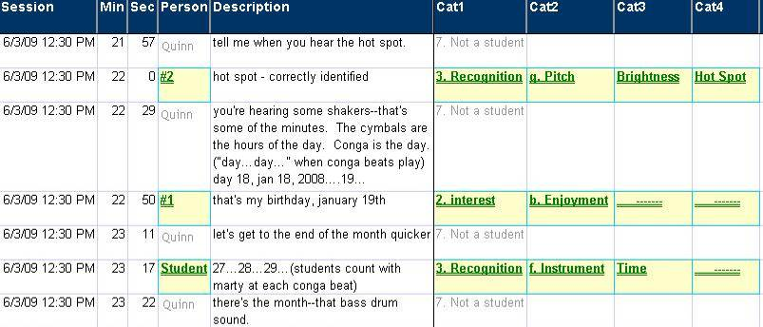
Cat1 is the category of attributes that separates events into levels of student responses, Recognition being deemed a higher level of response than an expression of interest. Cat2, Cat 3, and Cat 4 further subdivide these responses into levels, e.g., from simple recognition of an instrument to mapping that instrument to a color or time segment of mapping a pitch to brightness or, better, to associating a high pitch to a hot spot.
Note: Numbers and letters preceding category items were used for sorting purposes in the preliminary analysis as well as to indicate level of engagement on the part of the student. In Category 1, only records scored as 2. Interest, 3. Recognition, or 4. Extension were included in the results. Other records provided contextual information, e.g., records scored 1. Movement indicated participants coming onto or leaving the projection area, but not exhibiting interest in or recognition of concepts presented in the exhibit; records scored 7. Not a student indicated actions taken by the presenter or participants’ teachers.
B. VIDEO SCORING
Records in the log were scored for indications that the participating students exhibited behavior that could be characterized as:

- Interest in the exhibit – a necessary pre-condition for users adopting and adapting to the technology. Interest was further detailed, as shown below, to indicate increasing levels of engagement with the technology:
  - Limited reaction, e.g., following directions to walk on the image
  - Enjoyment, e.g., clapping, dancing on the images, or expressions such as “Whoa; Very different”
  - Investigation, e.g., self-directed moving arms or walking
  - Comment, e.g., “When I was watching the Olympics, Michael Phelps, I could hear what was going on on TV, I could hear them swimming, doing tricks”
  - Question, e.g., “What’s that?” “How come?” “How are you doing that?”

- Recognition of variations in sound and the concepts they are meant to convey. Recognition was further detailed to indicate engagement with or understanding of the concepts presented.
  - Investigation, e.g., purposeful exploration when asked to find a hot spot
  - Comment, e.g., “It helped me understand better because I thought you could only see what happens--I didn't know you could hear what happens.”
  - Question, e.g., “What’s an aurora?”
  - Variation, e.g., student walks around tracing the edge of the sun on an image
  - Instrument e.g., did the student recognize an instrument, e.g., a guitar, and, if so, did they
  - map the instrument to color e.g., saying “blue” when a guitar is played or
  - relate a percussion instrument to time, e.g., marking passage of a year
  - Pitch, i.e., the student extends this to level of brightness, e.g. calling out “whoa, bright”…or extends further indicating he or she hears a hot spot

- Extension of the exhibit’s technology beyond the concepts or uses presented, e.g., for physical therapy, in a portable version.

This schema is summarized visually on the next page.
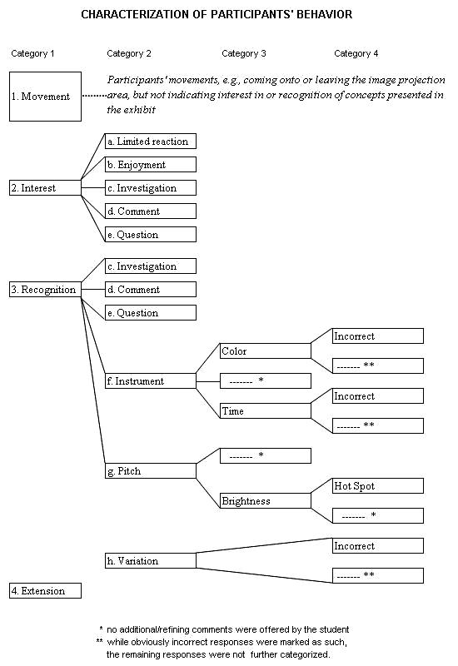
C. CASE STUDIES
Write-ups for each of the four case studies include summary tables showing instances of interest and recognition by participants. The numbers inside the tables for each case study are “roll-ups” from the raw data set.
The columns labeled #1 through #5 refer to individual students as identified by the numbered bibs they were given to wear. Column #? was used to record reactions that could not be associated with a particular student. “Multiple” was the column used where more than one student reacted at the same time in the same way and could not be separately identified.

Category 1 | Category 2 | Category 3 | Category 4 | Student
 |  |  |  | #1 | #2 | #3 | #4 | #5 | #? | Multiple | Total
Recognition | c. Investigation | ------- | ------- |  | 3 | 8 |  |  |  |  | 11
 | d. Comment | ------- | ------- |  | 2 |  | 1 | 1 | 1 | 1 | 6
 | e. Question | ------- | ------- |  | 1 |  |  | 1 |  |  | 2
 | f. Instrument | ------- | ------- |  |  | 1 | 3 | 1 | 5 |  | 10
 |  | Color | ------- | 2 | 1 |  |  |  | 5 |  | 8
Example: In the example above, Student #1 recognized an instrument and was able to associate it with a color two times during the session. In total during the session, students recognized an instruments 10 times and in addition correctly mapped a sound or an instrument to a color 8 times.
CASE STUDY #1: June 2, 2009, 10:30 AM
Participants: 6 middle school students, all generally well-functioning cognitively.
- 3 totally blind - Bibs #2, #5, #6
- 3 with limited sight - Bibs #1, #3, #4
Were the students interested in the exhibit/technology?
All of the students were sufficiently engaged to follow directions to move while on the projected images. All but subject #1, who had the least amount of one-on-one time with the technology, exhibited interest in several additional ways during the presentation.
Examples:
- #2: “It was fun moving around; didn't want to stop”
- #3: “I liked to dance; I learned how to make different music by moving my body from the old floor to the sun floor.” While on the image #3 spent much of the time twirling and dancing.
- #4: Commented “I learned how to make song by waving hand.”
- #5: Referring to an image that was displayed, asked “Was it really from December 2007?”
- #6: Tried out different hand movements to "scan" image.
Did the students recognize the variations in sound and map them to the visual images or solar concepts displayed?
All of the participants in this session indicated at least once that they were able to map an instrument to a color or identify the passage of time with a percussive instrument. For instance,
- #2: As another student dances on a solar wind image, #2 who is totally blind correctly indicates that “There is blue in there”
- #5: Noted the change in year with the big cymbal crash
- #6: Particularly attentive to pitch and relating it to hot spots
Possible extensions
Many of the participants’ comments related to the joy of movement and making music from the exhibit. Teachers pointed out that body awareness and physical therapy are important elements in developing functional independence in visually impaired students with multiple disabilities and they could see Light Runners’ technology contributing to this.
One of the totally blind students (#5) noted that “When I was watching [the] Olympics, Michael Phelps, I could hear what was going on on TV, I could hear them swimming, doing tricks. “ Light Runners’ inventor noted that he had considered possible extensions to artistic and athletic events such as placing a cameras over a pool during a swimming meet so the visually impaired could hear the progress down the lanes.
SESSION: 06/02/2009 10:30 AM |  | Grades: 7-9 |  | Student (Bib#)
Category1 | Category2 | Category3 | Category4 | #1 | #2 | #3 | #4 | #5 | #6 | #? | Mult | Total
Vision |  |  |  | yes | no | some | some | no | no
Time Spent on Image (min:sec) |  |  |  | 02:15 | 10:10 | 02:50 | 03:00 | 03:30 | 04:08
Interest | a. Limited reaction | ------- | ------- | 6 | 11 | 4 | 7 | 5 | 2 |  |  | 35
 | b. Enjoyment | ------- | ------- |  | 3 | 7 |  |  |  |  | 8 | 18
 | c. Investigation | ------- | ------- |  | 3 | 13 |  | 1 | 5 |  | 1 | 23
 | d. Comment | ------- | ------- |  | 1 |  | 3 | 3 | 1 |  |  | 8
 |  |  | Incorrect |  |  |  |  |  | 1 |  |  | 1
 | e. Question | ------- | ------- |  | 2 |  |  | 2 | 6 |  |  | 10
Interest Total |  |  |  | 6 | 20 | 24 | 10 | 11 | 15 |  | 9 | 95
Recognition | c. Investigation | ------- | ------- |  | 3 | 8 |  |  |  |  |  | 11
 | d. Comment | ------- | ------- |  | 2 |  | 1 | 1 | 2 | 1 | 1 | 8
 | e. Question | ------- | ------- |  | 1 |  |  | 1 |  |  |  | 2
 | f. Instrument | ------- | ------- |  |  | 1 | 3 | 1 | 2 | 5 |  | 12
 |  | Color | ------- | 2 | 1 |  |  |  | 7 | 5 |  | 15
 |  |  | Incorrect |  |  |  |  |  | 3 |  |  | 3
 |  | Time | ------- |  |  | 3 | 1 | 4 | 5 |  |  | 13
 |  |  | Incorrect |  |  |  |  |  | 1 |  |  | 1
 | g. Pitch | ------- | ------- |  | 1 |  | 1 | 4 | 9 | 1 |  | 16
 |  | Brightness | ------- | 2 | 1 | 4 | 1 | 4 | 11 |  |  | 23
 |  |  | Hot Spot |  |  |  |  | 1 | 6 |  | 1 | 8
 | h. Variation | ------- | ------- |  | 3 |  |  | 1 | 7 |  |  | 11
Recognition Total |  |  |  | 4 | 12 | 16 | 7 | 17 | 53 | 12 | 2 | 123
4. Extension | ------- | ------- | ------- |  |  |  |  | 2 |  |  |  | 2
4. Extension Total |  |  |  |  |  |  |  | 2 |  |  |  | 2
Total |  |  |  | 10 | 32 | 40 | 17 | 30 | 68 | 12 | 11 | 220

CASE STUDY #2: June 2, 2009, 1:00 PM
Participants: Middle School Students
- 3 totally blind - Bibs #2, #7, #8
- 5 with limited sight - Bibs #1, #3, #4, #5, #6
Were the students interested in the exhibit/technology?
The students were engaged in the presentation and anxious to try out the technology. Several called out words of encouragement to classmates to dance or move around more on the images
Examples:
- #3: “I liked the colors of the universe--bright”
- #2: “I liked the high pitch of the sound”
- Multiple Students: “Awesome”, “Wow” as students created music while moving over images
Did the students recognize the variations in sound and map them to the visual images or solar concepts displayed?
All of the students responded correctly to questions regarding which instruments were used and their pitch. Students responded with “yes”, “no” and “wow” on many occasions to questions regarding variation in color and heat. There were more spontaneous responses to questions regarding the use of instruments to mark time. Some responses were incorrect, but represented a small percentage of overall responses.
- #8: Appeared to use walking cane to deliberately explore for and find the edge of the Sun while walking on image
- #3: “Very hot; big star”
- Unidentified Student: “Right there; got it” (after being asked to listen for a hot spot and on hearing a high pitched sound)
- #5: “It got high then it got a low pitch” (after another student walked across image from light to dark). While on an image, #5 explored the edge between the Sun and space and used hand movements to isolate a sunspot
During the wrap-up to the session, a teacher asked "What about when you were on the image? Did that help you understand space or the Sun a little bit better?" There were multiple "yes" responses. The teacher directed a more specific question to student #3: "How did it help you understand a little better?" Student #3 responded : “It helped me understand a little better because I thought you could only see like oh like [sic] what happens--I didn't know you could actually hear sometimes what happens.”
SESSION: 06/02/2009 01:00 PM |  | Grades: MS |  | Student (Bib#)
Category1 | Category2 | Category3 | Category4 | #1 | #2 | #3 | #4 | #5 | #6 | #7 | #8 | #? | Mult | Total
Vision |  |  |  | some | no | some | some | Some | some | no | no
Time Spent on Image (min:sec) |  |  |  | 03:24 | 03:45 | 03:06 | 02:35 | 01:50 | 03:48 | 02:13 | 08:35
Interest | a. Limited reaction | ------- | ------- | 3 | 10 | 6 | 6 |  | 8 |  | 15 | 4 | 3 | 55
 | b. Enjoyment | ------- | ------- | 1 |  | 1 |  |  |  |  | 2 |  | 16 | 20
 | c. Investigation | ------- | ------- | 7 |  | 3 |  | 4 |  | 2 | 11 | 2 |  | 29
 | d. Comment | ------- | ------- | 1 | 1 | 1 | 1 | 1 |  |  |  | 2 | 5 | 12
 |  |  | Incorrect |  |  |  |  |  |  |  |  |  | 2 | 2
 | e. Question | ------- | ------- |  |  |  | 1 |  |  |  |  | 1 |  | 2
Interest Total |  |  |  | 12 | 11 | 11 | 8 | 5 | 8 | 2 | 28 | 9 | 26 | 120
Recognition | d. Comment | ------- | ------- |  | 1 | 1 | 1 |  |  |  |  |  |  | 3
 | e. Question | ------- | ------- |  |  |  |  |  |  |  |  | 1 |  | 1
 | f. Instrument | ------- | ------- | 1 | 1 | 2 | 1 | 2 | 1 |  | 1 | 4 | 1 | 14
 |  |  | Incorrect |  |  |  | 1 |  |  |  |  |  |  | 1
 |  | Color | ------- |  |  | 1 | 1 |  |  |  | 1 | 4 |  | 7
 |  | Time | ------- | 4 | 4 | 2 | 4 | 4 |  | 4 | 1 | 1 | 1 | 25
 |  |  | Incorrect | 1 |  | 1 |  |  |  | 2 | 1 |  | 1 | 6
 | g. Pitch | ------- | ------- |  | 1 |  |  | 3 |  |  | 1 |  | 3 | 8
 |  | Brightness | ------- | 3 | 3 | 3 | 2 | 6 | 2 | 2 | 1 | 4 | 6 | 32
 |  |  | Incorrect | 1 |  |  |  | 1 |  | 1 |  |  |  | 3
 | h. Variation | ------- | ------- | 1 | 7 | 3 | 12 | 3 |  | 4 | 1 |  | 1 | 32
 |  |  | Incorrect |  |  |  |  |  |  |  |  | 1 |  | 1
Recognition Total |  |  |  | 11 | 17 | 13 | 22 | 19 | 3 | 13 | 7 | 15 | 13 | 133
Total |  |  |  | 23 | 28 | 24 | 30 | 24 | 11 | 15 | 35 | 24 | 39 | 253

CASE STUDY #3: June 3, 2009, 9:00 AM
Participants: grade level - High School
- # totally blind - Bibs #9
- # with limited sight - Bibs #1-8, #10
Were the students interested in the exhibit/technology?
All of the students showed some level of interest, most of them actively investigated the images and their sound-making capabilities.
Examples:
- #2: “felt like we were on a field trip, even though we didn't physically leave the school”
- #8: “Is there another stringed instrument in there?”
- #9: {Upon hearing a cymbal crash} “how many years have we passed?”
Did the students recognize the variations in sound and map them to the visual images or solar concepts displayed?
All but #6 and #10 were heard to recognize a hot spot at least once; six of the ten participants were heard to associate a color with a sound. The one totally blind student scored on both counts and asked half of all the questions noted, e.g.,” how many years have we passed? (after hearing a lots of big cymbal crashes)
- #4: [Comment when the pitch rose}"Ooh, sunburn!"
- #9: {Upon hearing a cymbal crash} “how many years have we passed?”
Possible extensions
Student #2 noted that the program “felt like we were on a field trip, even though we didn't physically leave the school.” While real field trips provide learning opportunities, locating sonification technology at a school would enable faculty in any subject area to bring visual aides to the technology site and facilitate and augment a virtual field trip for students
SESSION: 06/03/2009 09:00 AM |  | Grades: HS |  | Student (Bib#)
Category1 | Category2 | Category3 | Category4 | #1 | #2 | #3 | #4 | #5 | #6 | #7 | #8 | #9 | #10 | #? | Mult | Total
Vision |  |  |  | some | some | some | some | some | some | some | some | no | some
Time Spent on Image (min:sec) |  |  |  | 04:00 | 00:18 | 04:24 | 02:50 | 00:26 | 01:10 | 00:28 | 06:28 | 04:17 | 02:04
Interest | a. Limited reaction | ------- | ------- | 1 |  | 1 | 4 |  |  |  | 2 | 2 |  |  |  | 10
 | b. Enjoyment | ------- | ------- |  |  | 1 | 2 |  |  |  |  | 1 |  |  | 13 | 17
 | c. Investigation | ------- | ------- | 7 | 1 | 8 | 2 | 2 | 3 | 1 | 6 | 9 | 3 |  |  | 42
 | d. Comment | ------- | ------- | 4 |  | 4 | 3 | 2 | 1 |  |  |  | 1 |  | 5 | 20
 |  |  | Incorrect |  |  |  |  |  | 1 | 1 | 1 | 1 | 1 | 2 |  | 7
 | e. Question | ------- | ------- | 1 |  | 1 | 1 |  |  |  | 1 | 5 |  | 1 |  | 10
Interest Total |  |  |  | 13 | 1 | 15 | 12 | 4 | 5 | 2 | 10 | 18 | 5 | 3 | 18 | 106
Recognition | d. Comment | ------- | ------- |  |  |  |  |  |  |  |  |  |  |  | 1 | 1
 | f. Instrument | ------- | ------- | 1 | 1 | 1 | 1 | 2 |  |  |  | 2 |  | 5 |  | 13
 |  |  | Incorrect |  |  |  |  |  |  |  |  |  |  | 1 |  | 1
 |  | Color | ------- | 4 |  | 1 | 1 | 2 |  |  | 2 | 1 |  | 1 |  | 12
 |  | Time | ------- |  |  |  |  |  |  |  |  | 1 |  |  | 1 | 2
 | g. Pitch | ------- | ------- |  |  | 1 | 1 | 1 |  |  |  | 1 |  |  |  | 4
 |  | Brightness | ------- |  |  |  |  |  |  |  | 1 |  |  | 2 |  | 3
 |  |  | Hot Spot | 4 | 1 | 3 | 1 | 3 |  | 2 | 3 | 2 |  |  | 1 | 20
 |  |  | Incorrect |  |  |  |  |  |  |  | 1 | 1 |  |  |  | 2
 | h. Variation | ------- | ------- |  |  | 2 | 1 |  |  |  |  | 1 |  |  |  | 4
Recognition Total |  |  |  | 9 | 2 | 8 | 5 | 8 |  | 2 | 7 | 9 |  | 9 | 3 | 62
4. Extension | ------- | ------- | ------- |  | 1 |  |  |  |  |  |  |  |  |  |  | 1
4. Extension Total |  |  |  |  | 1 |  |  |  |  |  |  |  |  |  |  | 1
Total |  |  |  | 22 | 4 | 23 | 17 | 12 | 5 | 4 | 17 | 27 | 5 | 12 | 21 | 169

CASE STUDY #4: June 3, 2009, 12:30 PM
Participants: First Grade
- # totally blind - Bibs #1, #8
- # with limited sight - Bibs #2, #3, #4, #5
Were the students interested in the exhibit/technology?
This was a very energetic group of seven-year-olds. All of the participants were highly engaged and expressed interest in the technology. They spent much of their individual time on the images in what might best be characterized as dancing.
Examples:
- #5: “it was the funnest thing I've ever done”
- #2: “I'm dancing!” (shakes legs/arms)
- Multiple students: calling out encouraging the student on the image to dance.
Did the students recognize the variations in sound and map them to the visual images or solar concepts displayed?
All of the students were observed to correctly map a color at least once and were even more responsive to marking the passage of time in response to the various percussion instruments.
- #1: while turning head back and forth, says “I hear light, darkness, light darkness”
… #2: Comment after another student walks across a gradient image. – “[Sound] goes from “grr” {student makes a low pitched sound} to “eee” {student makes a high pitched sound} …“One million degrees sounds like this: ahhh” {Student makes a very high pitched sound}

Notable: #3 showed little reaction for 38 minutes into the session compared with her highly active classmates; however, when given the chance to walk on the images, rather than dancing, she exhibited purposeful movements tracing edges, at one point returning to the light center with no one guiding her and commenting, "It's light".

SESSION: 06/03/2009 12:30 PM |  | Grades: 1st |  | Student (Bib#)
Category1 | Category2 | Category3 | Category4 | #1 | #2 | #3 | #4 | #5 | #8 | #? | Mult | Total
Vision |  |  |  | no | some | some | some | some | no
Time Spent on Image (min:sec) |  |  |  | 04:05 | 03:40 | 04:19 | 03:23 | 01:42 | 09:01
Interest | a. Limited reaction | ------- | ------- | 3 | 2 |  | 2 | 1 | 8 |  |  | 16
 | b. Enjoyment | ------- | ------- | 3 | 4 | 3 | 1 | 2 | 3 |  | 5 | 21
 | c. Investigation | ------- | ------- | 7 | 9 | 9 | 7 | 5 | 16 |  | 1 | 54
 | d. Comment | ------- | ------- | 4 | 4 |  | 2 | 2 | 1 | 1 | 3 | 17
 |  |  | Incorrect |  | 1 |  |  |  |  |  |  | 1
 | e. Question | ------- | ------- | 9 | 11 | 1 |  | 7 | 2 | 1 | 1 | 32
Interest Total |  |  |  | 26 | 31 | 13 | 12 | 17 | 30 | 2 | 10 | 141
Recognition | d. Comment | ------- | ------- | 2 |  |  |  |  |  |  |  | 2
 | e. Question | ------- | ------- | 1 |  |  |  |  |  |  |  | 1
 | f. Instrument | ------- | ------- |  |  | 1 |  | 2 |  |  |  | 3
 |  | Color | ------- | 1 | 1 | 1 | 3 | 1 | 2 |  | 1 | 10
 |  | Time | ------- | 2 | 3 | 1 | 1 | 2 | 5 |  | 1 | 15
 |  |  | Incorrect |  |  |  | 1 |  |  |  |  | 1
 | g. Pitch | ------- | ------- |  | 6 |  |  |  |  |  |  | 6
 |  | Brightness | ------- | 1 | 1 |  |  |  |  |  |  | 2
 |  |  | Hot Spot | 2 | 9 | 1 | 1 |  | 1 |  | 1 | 15
 | h. Variation | ------- | ------- |  |  |  |  |  | 1 |  |  | 1
Recognition Total |  |  |  | 9 | 20 | 4 | 6 | 5 | 9 |  | 3 | 56
Total |  |  |  | 35 | 51 | 17 | 18 | 22 | 39 | 2 | 13 | 197

PART IV. CONCLUSIONS AND RECOMMENDATIONS
A. CONCLUSIONS
Observation of visually impaired participants in Light Runners’ “Walk on the Sun” project suggests that:
- it captures their interest;
- it provides them with an enjoyable interactive musical experience; and
- they recognize variation in instruments and the pitch at which they are played.
There is evidence to suggest that higher cognitively functioning students can learn to:
- recognize the links between their movement, pixel selection, and music generation;
- map instruments to color;
- through pitch, identify the location of scientific phenomena such as hot spots;
- through certain percussive instruments, recognize the passage of time in the presentation of a sequence of sonified digital images.
Recognition of Instrument and Pitch is a necessary condition for users to benefit from Light Runners’ technology. Further mapping the instrument and pitch to color, brightness, and the passage of time facilitates use by – or communication regarding – the image with sighted people. However, mapping isn’t inherently necessary for sonification to be useful to those who have been profoundly blind from birth. If Light Runners technology enables those with no concept of color or light to recognize variation, it is possible to teach them to use it to enjoy and analyze images, scientific or otherwise, through music.
Co-Investigator Martin Quinn, the developer of the Light Runners project technology, was the presenter for all of the evaluation sessions. Quinn is also a gifted musician and the technology’s efficacy in extending art and music appreciation to the visually impaired is evident from the interest and enjoyment displayed by participants in the videoed evaluation sessions as well as in testimonials. However, Co-I Quinn’s relatively lower level of comfort with the scientific subject matter is also evident in that presentations emphasized the technical and musical aspects of the project. Consequently, there were insufficient data points on which to base an evaluation of the project’s efficacy in science education and specifically solar science, although a basis for this could be inferred from users’ ability to discern visual variations from their sonic representations. More science content and a stricter adherence by the presenter to a script or curriculum are required to make such judgments. However, not doing so in this instance uncovered variables which might have been missed in a more structured analysis. The design of future evaluations will need to take into account differences in age, cognitive ability, degree of blindness, and memory of vision.
B. RECOMMENDATIONS:
INCORPORATING TEACHERS’ COMMENTS AND OTHER TESTIMONIALS
Analysis of the videoed sessions suggested the following areas for enhancing the exhibit, particularly its science education component:
Spend more time on the basics and avoid leading questions. While it is important to capture the new user’s interest with melodic applications of the technology, those who are expected to use the technology over a longer term to explore more complex concepts need to spend more time on the basics. The presenter could employ a deliberate and gradual approach, introducing sonification concepts by spending even more time with the simplified gradients developed to demonstrate color and pitch and directing the user to demonstrate their understanding of mapping “instrument to color or time” and “pitch to brightness” without the use of leading questions.
Color Gradient Monochromatic Gradient to Demonstrate Pitch
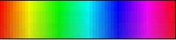
For example, rather than selecting a hot spot on a solar image and asking if the student hears a hot spot, ask the student to find the highest and lowest pitch on a monochromatic gradient image and then ask which area they think represents something hot and which represents something cold.
Limit the use of undirected movement when teaching scientific concepts. Unrestricted dancing over the solar images was cited by both a teacher and a student as a potentially very useful application of sonification technology, both as physical therapy and as a means of encouraging more body awareness and confidence in the visually impaired. However, when using the technology to demonstrate and evaluate its usefulness for science education, a more significant amount of time needs to be devoted to developing such skills as identifying variation in color and brightness, tracing edges, or locating solar phenomena.
Turn the tracking off while instructing. Frequently during the evaluation, explanations were drowned out by or shouted over the music. The sonification device should be turned off while instructing…otherwise the two audio channels will be difficult for the listener to process.
Increase the amount of time spent on individual images. NASA’s STEREO space mission produced a digital treasure trove of images. Over time, as a visually impaired user becomes more adept with the technology, it may be possible to increase the rate at which these images are employed by the exhibit. However, the novice user without a visual reference cannot quickly assess whether the changing sonification represents movement within a single image they are attempting to interpret or jumps among a rapidly changing set of images.
Extend the technology to work in conjunction with tactile teaching tools. Teachers were particularly interested in supplementing existing tactile teaching tools with sound clues. Of possible interest might be a project sonifying a book such as Noreen Grice’s Touch the Universe: A NASA Braille Book of Astronomy.
“The ones [referring to students] who never had vision –they can’t make a picture in their heads. Oh, obviously! Some of them can go back and [naming a student] had some vision. … But I have other students that have never had any. … So without something like this [showing Co-I Quinn one of Noreen Grice’s tactile books on Astronomy], they’re lost. … When I explain things to my students, I say, “Okay now tell me about the picture you have in your head.” They may flip flop and turn it on its side, reverse it. So giving them this [pointing to tactile book] to anchor it after entering that [pointing to “Walk on the Sun” image projected on the floor], then they can see. … It will complete this [pointing to the book]. … Absolutely. …I would give this [turning to a page in the book] to them, I would say this is what you’re stepping on [referring to “Walk on the Sun” image].  Teacher, Maryland School for the Blind, June 3, 2009, following 1:30 PM Evaluation Session | 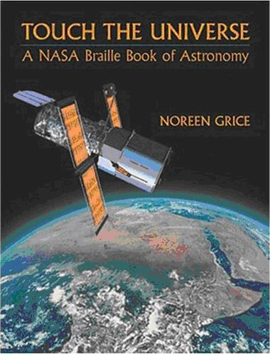  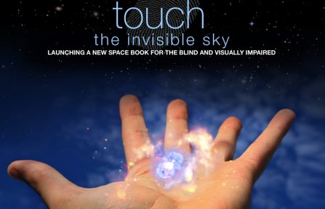
Extend the technology to assist with life skills. Teachers suggested possible extensions of the technology including facial recognition and independent mobility.
“… you could tell if someone walked by in a red shirt or if they were in a blue shirt and ... you could start to learn what their face looked like.”
“... crossing the street. Part of the problem with crossing right now is that a lot of times they depend on moving traffic to know when it’s safe to cross ... so with the creation of silent cars and silent engines, how do you know that there’s not a car waiting there to turn? How do you know something’s not coming from further away. I mean it would take a lot of training...but they’re learning to understand that sound – that’s a car coming – I know not to cross.”
Teacher, Maryland School for the Blind, June 2, 2009, 2:00 PM Evaluation Session
Demonstrate economic viability. There is a lot of educational technology on the market and schools have limited budgets. The current cost of the sonification technology would be difficult to justify for science applications alone. However, the economic feasibility of sonification is enhanced by its wide applicability both in subject areas and age range. Teachers noted many potential non-science applications e.g., art and music education, physical therapy, and life style enhancement, and the evaluation videos demonstrated the technology to be usable by a wide age range of students.
Include content experts in the presentation sessions . As was noted in the introductory overview, the major deficiency with the project was the lack of a presenter/co-presenter with both the complementary pedagogical skills and content expertise required to better utilize the technology to deliver science education to the visually impaired. The project’s design and funding did not allow Co-Investigators (Peticolas, McDonald) with STEREO content expertise and pedagogical skills to accompany Co-I Quinn to the demonstration sites. In retrospect, the project might have been improved with fewer site visits so that funding would allow for a content and pedagogical expert to participate with the technology developer in the sessions. However, several science educators for the blind expressed their interest in the project and the belief that it could be deployed to very great advantage in the classroom. Future funding requests might focus on collaborating on an intensive deployment of the technology in the classrooms of a partner school for the purposes of:
- developing a student curriculum; and
- providing professional development seminars for educators - perhaps at conferences sponsored by the National Federation for the Blind’s Jernigan Institute or their National Center for Blind Youth in Science
This would provide the basis for the next level of evaluation of the effectiveness of sonification technology in science education for the visually impaired.

High School Student, June 3, 2009, 1:30 PM Evaluation Session … “I was thinking if the school were to get one of these things, they should just make it like a building that has this scientific stuff and explains this stuff. So it could be just for that purpose, so if anyone needs to use it for anything even [if] it was just for physical therapy...they would come to that building, so they wouldn’t buy a whole bunch.“
Art Teacher being experiencing the exhibit, June 2, 2009, prior to 10:00 Evaluation … “Oh my god ... I love it …It’s amazing, it’s amazing; I’m really thrilled …I could be here for hours … How am I going to follow this act ... absolutely love it...can we run through the universe again?“
Maryland School for the Blind

